In order to implement our system, we have used several tools, technologies and frameworks. The main tools and frameworks were selected carefully as we know how these tools plays a signification role and affect the system's development process.

For instance, we have used JavaScript and Node.js for server-side scripting among other language such PHP and Python, as JavaScript is more commonly used and ranked as the top popular language. (See figure XXX) Moreover, JavaScript is more suitable for systems that require real time communication as in our case. Having the same language on both Front-end and back-end make was a bonus for us and eased the maintainability.

Below, we listed the main tools and frameworks that we have used in different stage of implementing our project. In the second column of the table, we explained briefly the usage for each one and how it helped us through implementation of our project.

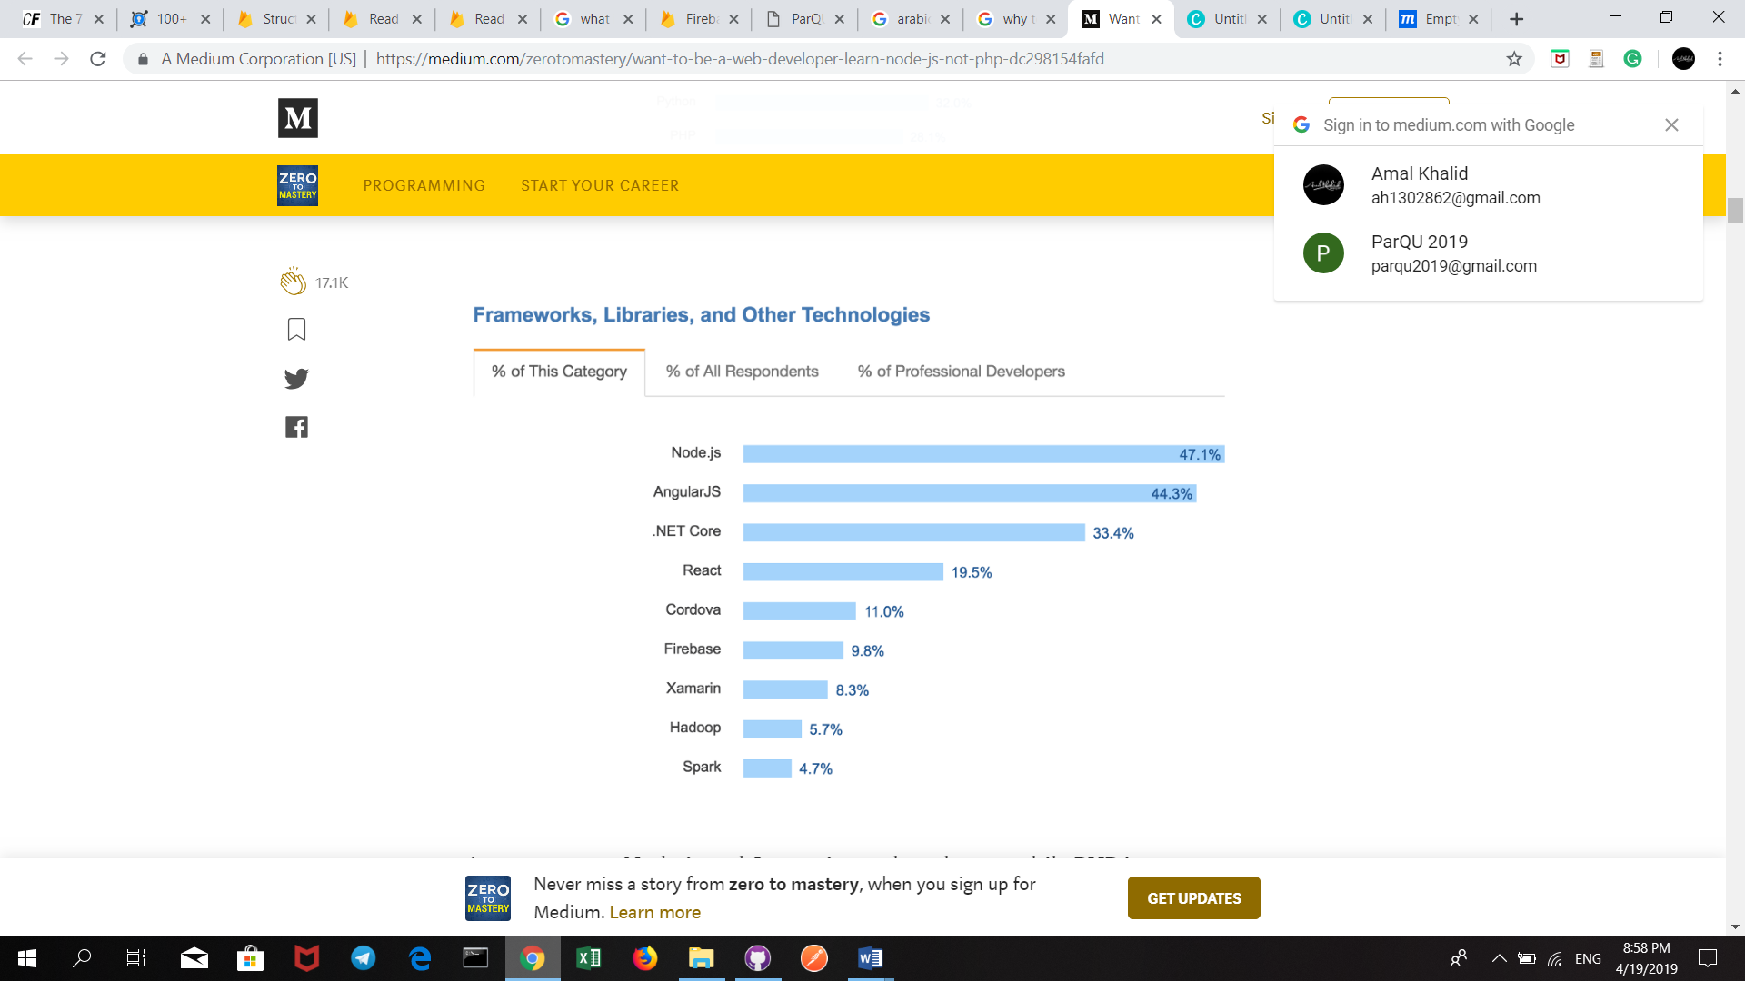

|  |  |
| --- | --- |
| Tools, frameworks and technologies | |
| Front-end Languages / Platforms | |
| HTML | Hyper Text Markup Language used to build the structure and the content of the website page |
| CSS | Style sheet language used for the presentation of web pages writing in HTML. |
| JavaScript | Programming language used for client-side scripting. |
| Front-end frameworks | |
| Bootstrap | An open-source CSS framework used to make the website responsive and allow the pages’ style to act differently based on the browser size. |
| Back-end frameworks and Libraries | |
| Node.js | An open-source, JavaScript run-time environment used to execute server-side scripting. |
| Realtime Firebase |  |
| Express Framework | Node.js framework used to make the HTTP requests such GET and POST requests. |
| Body-parser | Node.js middleware for handling JSON used to get the body from the request and work on it, and to get the data sent in the body. |
| Express-handlebars | Express module used to create dynamic front end pages using html. |
| Path | Node.js module used to set the css,js and images files and everything related to the frontend into public folder and access it from the pages. |
| App | JavaScript web application development framework used to Create instance form Express |
| Express-flash | Node.js module for flash messages for Express application. Used to display messages on success and on errors. |
| Express-session | Node.js module creates a middleware with the given options. We used it to save the session of the user. |
| Moment | A lightweight JavaScript date library for parsing and formatting dates. Used to make a lot of changes on the displaying, adding time or getting time difference. |
| Nodemailer | Node.js module used to send e-mail from Node.js |
| Task Runners / Package Managers | |
| NPM | Pack manager for JavaScript. |